District Attorney
County of

CA

RE: ,
NSH #
CT #:

Dear District Attorney:
This is to request that a petition for extension of commitment be filed in the case of the above individual. The enclosed material is offered as evidence that he qualifies for an extension pursuant to former Welfare and Institutions Code Section 63162 (continued in effect for persons still under commitment pursuant to statues of 1981, Chapter 928, Section 3, in that in his present status and condition, by reason of a mental disease, defect or disorder, and as a result, is predisposed to the commission of sexual offenses to such a degree that he represents a substantial danger of bodily harm to others.
Enclosed is a case summary stating the basis upon which this case is submitted for extension. Please contact me at (707) 253-5434 if further information or assistance is needed. When your office has filed a petition in this case and hearing has been calendared, please email the petition/notice and disposition of hearing along with a certified copy of the Order to Napa State Hospital, Attn: Forensic Services – Legal Records via email to NSH.CourtDocuments@dsh.ca.gov.
If it is the decision of your office that the patient does not meet criteria for extension of the commitment and therefore a petition will not be filed with the court, please advise this hospital in writing of such decision so that we may initiate plans for discharge at the end of the commitment term.
The maximum term expires on .
Sincerely,
Camille Morgan, Psy.D. for
Seth Judd, D.O., or Designee
Medical Director
12/15/2023

Enclosures
cc:

A F F I D A V I T

I, the Medical Director of Napa State Hospital, have legal responsibility for the care and treatment of [click & type] [click & type], NSH#[click & type], [click & type] County Superior Court #[click & type the court number].
I have reviewed the case and it is my opinion that the above-named individual qualifies for an extension of commitment under Section 1026.5, California Penal Code, in that in his present status and condition, by reason of a mental disease, defect or disorder, he represents a substantial danger of physical harm to others.
Therefore, I am recommending to the prosecuting attorney that application be made to the appropriate court for such extension of commitment.
The above opinion and recommendation is supported by the recent hospital case summary, which is attached and incorporated by reference.
I declare under penalty of perjury that the foregoing is true and correct to the best of my knowledge.
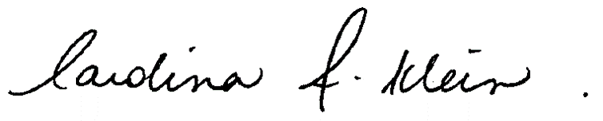
Medical Director or Designee
12/15/2023

